Special-Event Park-and-Ride Planning Problem
CEE 6410/5410
David Rosenberg
October 10, 2026

This problem was contributed by Dr. Ran Sun and expanded by Dr. David Rosenberg

Learning objectives.
Students will be able to:
- Define dimensions, decision variables and an objective function;
- Formulate demand, capacity, and service-quality constraints;
- Solve a small linear program;
- Identify constraints;

Problem Statement
State Department of Transportation guidance for special events emphasizes advance planning for transportation demand, traffic, parking, transit operations, and seating.

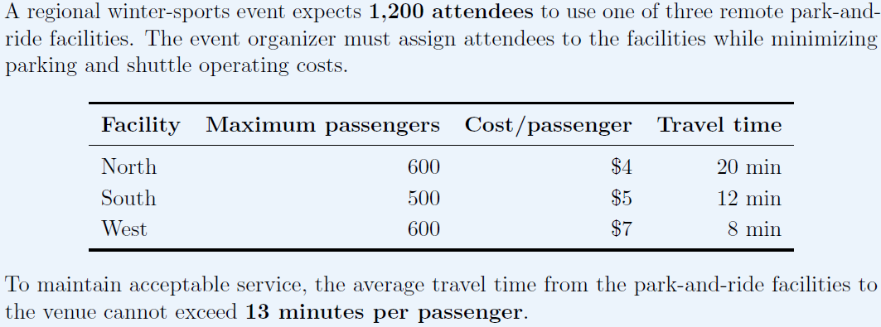

Passengers must also be assigned in full bus-loads of 50 passengers per bus.

Additionally, the event planners must rent and bring in grandstands for the attendees. They have 2 potential venders. Each vender has an up-front reservation cost, number of seats per grandstand, and cost to load, ship, and setup a grandstand.

Vendor | Reservation cost ($) | Seats per grandstand | Cost to load, ship, and setup  ($ per grandstand)
Purple Rain | $1,000 | 100 | 200
Blue Sky | $1,500 | 200 | 300

How many buses should the event planners schedule from each parking lot? How many grandstands should the event planners rent from each vendor?

Schematic

Dimensions

Decision Variables

Objective Function

Constraints

